WCSQM
Langley Park School for Boys – World Class Reaccreditation 2021

Student name: Jacob Byfield Year group/form: 12D

Instructions to student:
Choose an area. For each characteristic, write an explanation, and upload evidence. For each area, there is a poster to help you, and a version of this form with completed examples. Save as you go along.
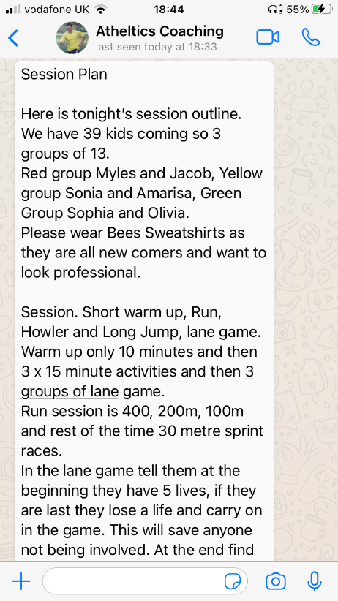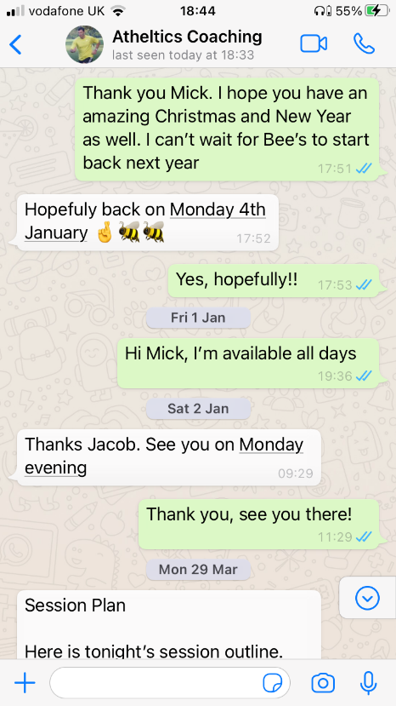3. I consistently out-perform students from similar contexts, and I am committed to continually improving my performance because I
a…know how to develop positive relationships with different groups of people
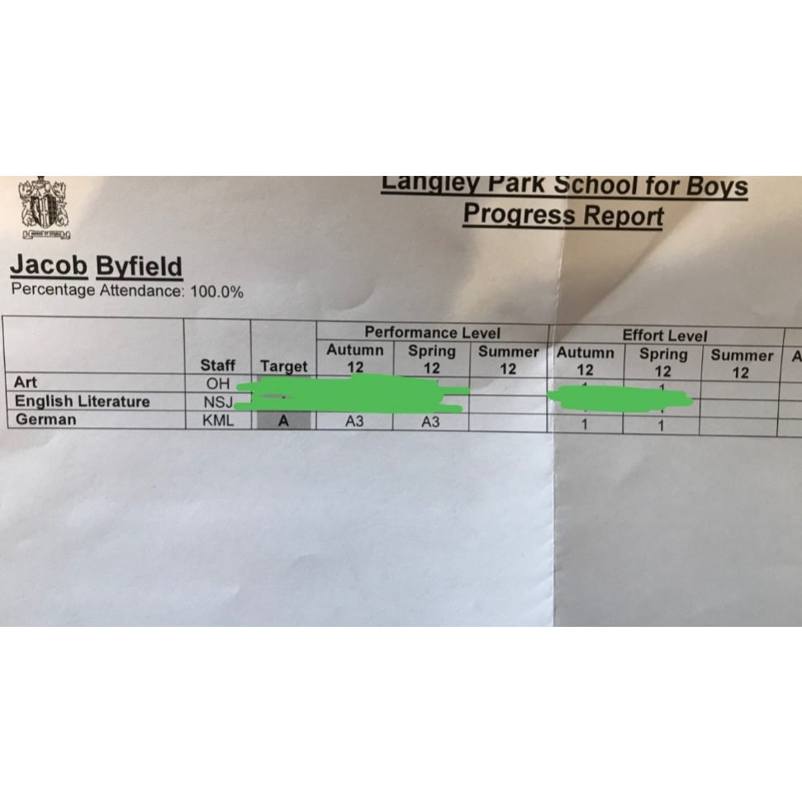For the last couple of years I have been working as an athletics coach, where I teach groups of children from the ages of about 4-14 many different skills, including teamwork and confidence. There is no doubt about the fact that communicating with some people may be difficult as the children can misbehave, and the parents sometimes start trying to tell me how to do my job, however it’s imperative for me to remember to treat people the way that I would like to be treated and make sure that everyone is not only enjoying themselves, but also learning a few skills along the way! There’s no doubt about the fact that being able to communicate with younger and older people from all walks of life is very gratifying and inspiring, as it’s a constant reminder that I can learn from anyone.
b…achieve my potential and overcome obstacles
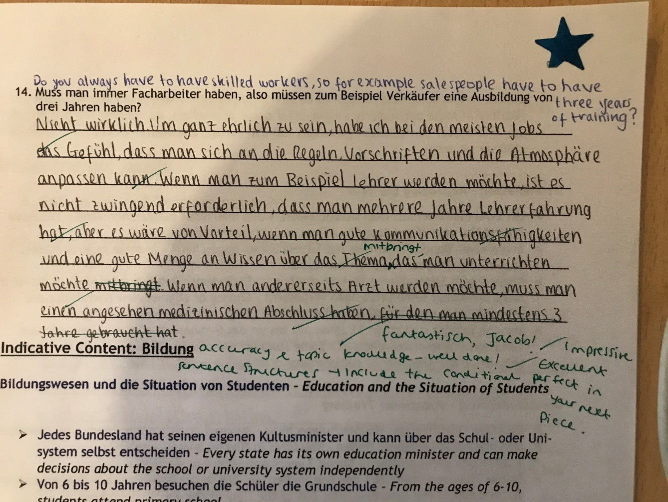In Year 12 I study three subjects – Fine Art, German and English Literature. It’s without saying that German is a very difficult subject because of the fact that unlike a few other people in my class, I’ve never been to Germany, nor had anyone I know study a foreign language after GCSE, and my family don’t come from a German speaking background, which means that I am often find the subject tough, as it sometimes feels like I’m counting on just myself to get good grades. However, I have a passion to know as much German as I can by the end of next year for my final exams, and perhaps even University, so I’m constantly having to persevere, which at the moment is paying off! I may not be able to understand the concepts and vocabulary straight away, but I’m currently working at a grade A which I’m very proud of myself for. Because of my love for this subject I will try my hardest to reach my full potential by acheiving an A*, but I know it’s going to be very hard to get.
c…have an area of expertise or specialism
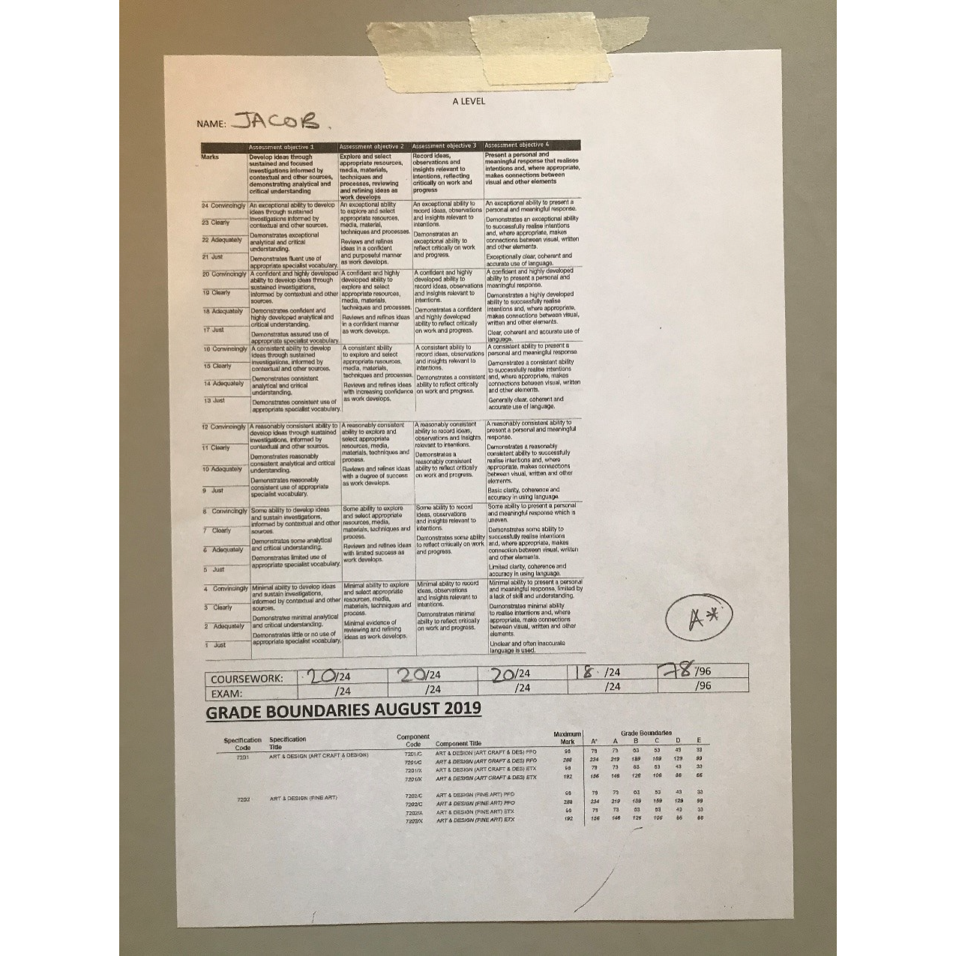Many people don’t know that I am a budding artist who really enjoys thinking ‘outside of the box’, where in my project at the moment, am exploring the themes of mental health, food addictions and expressions through art. The creative side of me has helped open my mind to new and original ideas, in order to push myself and broaden my thoughts and capabilities. Art is a very competitive subject, where I see myself constantly comparing myself to other people, but I’m always reminding myself to stay head-strong and confident in my skills and abilities. When I first started Art in Year 10, I would definitely say that I wasn’t very experimental or ‘talented’ per say; however at the moment, my book has been graded as an A* which I am really proud of myself for. I would say that because of all the articles I have analysed, essays I have written, and pieces of Art I have created over the last few years, I have become really knowledgeable on this subject, as it fascinates me a lot!
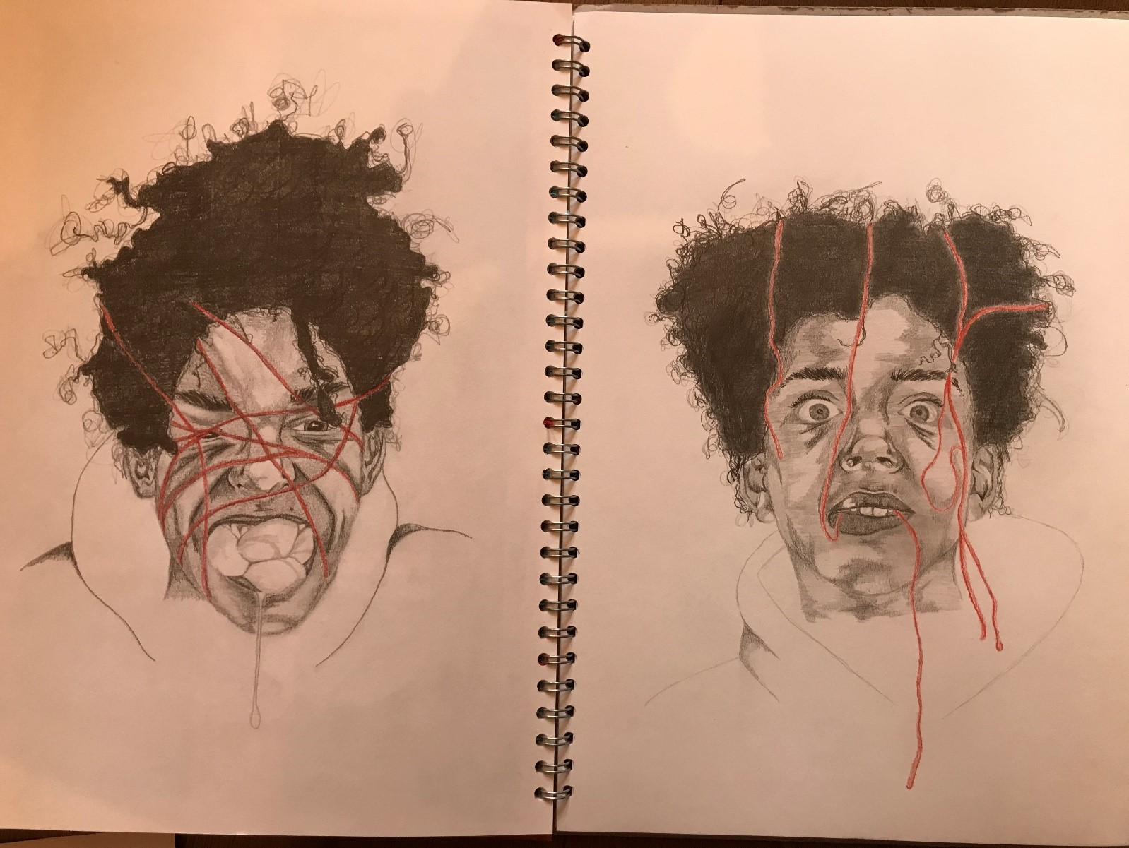
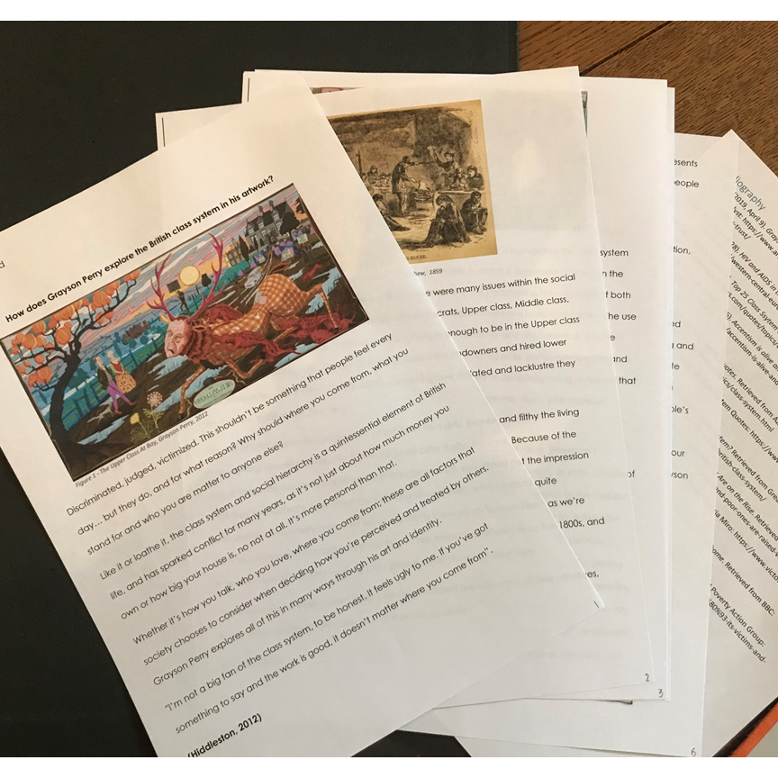
d…can demonstrate methods and tools of continual improvement
I would definitely say that my essay writing skills have come leaps and bounds. For example, because of my A-Level choices, I am not only writing English essays, but Art and German ones as well, which have been incredibly interesting to write/ type. Last year in Year 11, the majority of my essays were about analysing language in a novel, such as ‘Inspector Calls’. However this year, I was analysing and exploring how the artist Grayson Perry explores the British Class System. Into the bargain, this essay was added to the ‘Langley Academic Journal’, which I was very proud of. At the moment in German I am studying the film ‘Goodbye Lenin!’, and I’m looking forward to writing some in-depth essays about the characters, history of Germany and plot of the film etc.
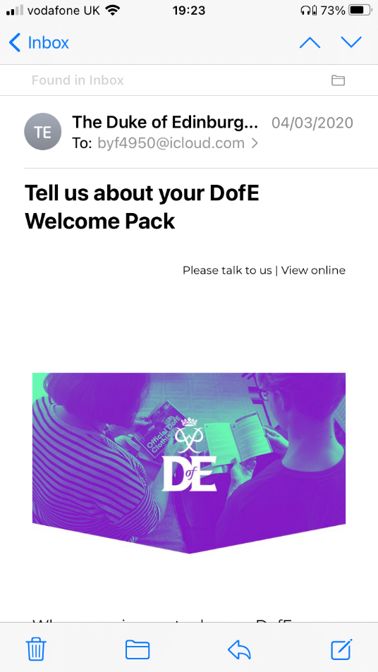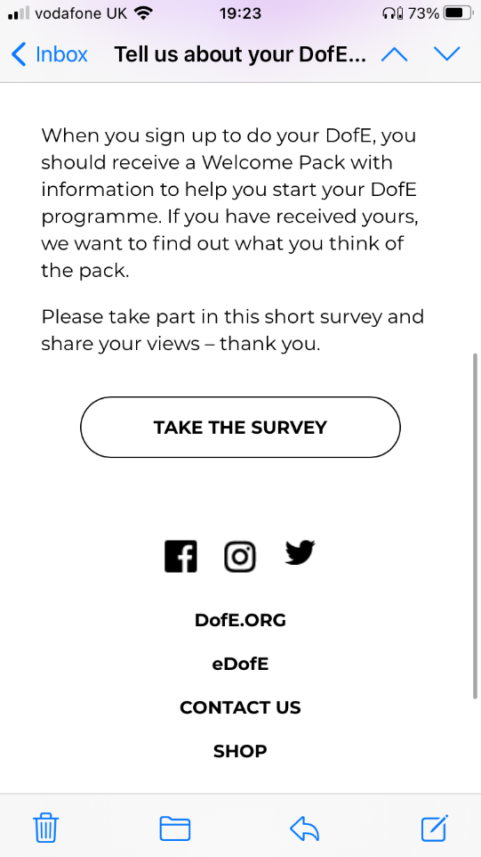e…am agile in response to changing needs and circumstances
I have taken part in the bronze DOFE award, meaning that I had to lead my expedition. There is no doubt about the fact that the 10-hour walks were challenging, tiring and often confusing, however I was able to communicate well with my group of 5 and contribute to form a successful plan on how to navigate ourselves around an area that we weren’t familiar with. I would say that I was adaptable to change, as we had to manoeuvre around the area and learn from our mistakes and move on/ progress from them. These quick decisions to work out what move to take next, had to be made quickly as we didn’t want to spend too much time standing around helplessly. Looking back on it, I am very proud of what I was able to achieve, and my group actually ended up finishing the expedition first, which we were all very proud of.
f…want to improve my learning continually
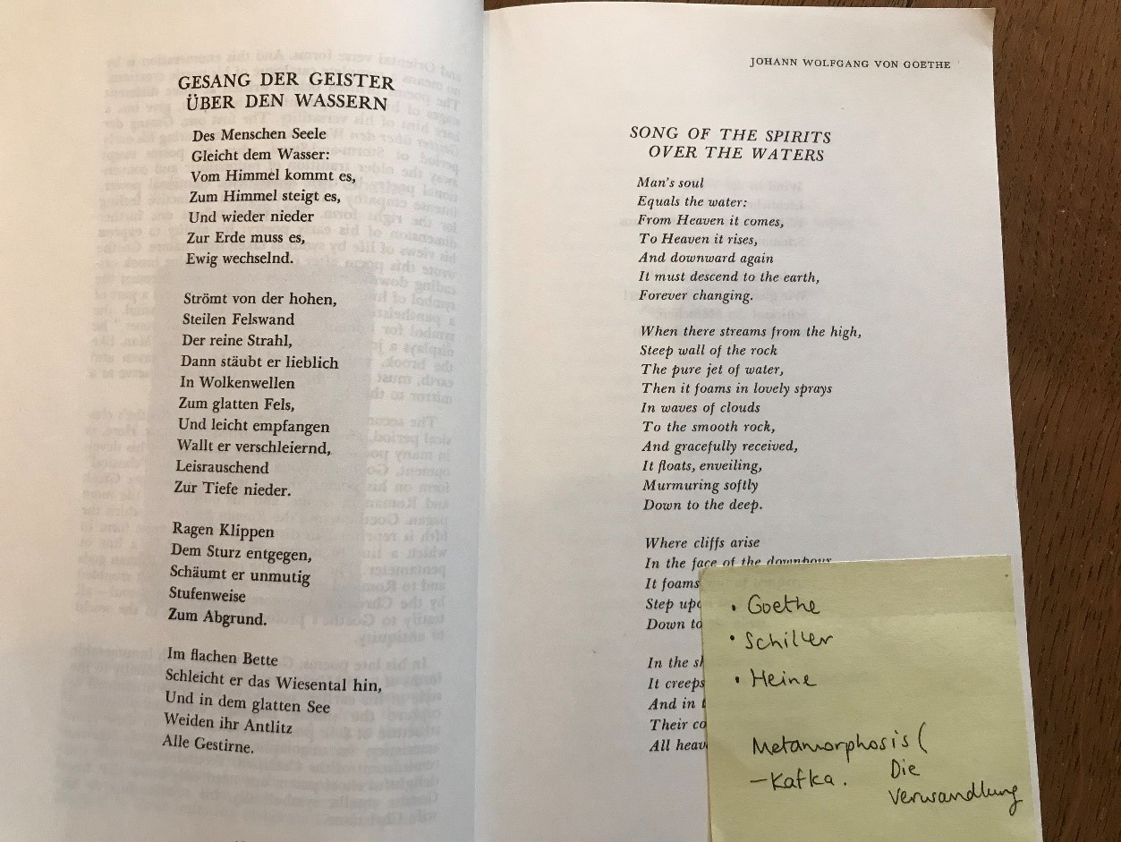At the moment, I am part of the CORGI group, meaning that I’ve been thankful enough to be introduced to a variety of workshops and courses. Recently, I signed up to a MOOC on German advanced culture which is going well. Not only that, but I have started listening to German podcasts and reading a few pieces of German literature that my teacher gave me, which has been utterly fascinating. Because of this, I’m able to understand their social, political and environmental status, showing how I go the extra mile to explore topics and subjects outside of the curriculum. Hopefully, this wider reading and listening will advance my skills in a more in-depth level, leading up to my Year 13 exams.

